EXPERIMENT – 5

PERFORM VARIOUS CONFIGURATIONS OF IPTABLES FIREWALL IN LINUX

AIM
To study and perform various configurations of the IPTABLES firewall in Linux to control incoming and outgoing network traffic.

REQUIREMENTS
Linux Operating System (Ubuntu / Kali Linux)
Root or sudo privileges
IPTABLES firewall utility

PROCEDURE

STEP 1: OPEN TERMINAL
Boot Linux system
Open Terminal
Switch to root user or use sudo
sudo su
STEP 2: VIEW CURRENT IPTABLES RULES
sudo iptables -L
STEP 3: FLUSH EXISTING RULES
sudo iptables -F
STEP 4: SET DEFAULT POLICIES
sudo iptables -P INPUT DROP
sudo iptables -P FORWARD DROP
sudo iptables -P OUTPUT ACCEPT
STEP 5: ALLOW LOCALHOST TRAFFIC
sudo iptables -A INPUT -i lo -j ACCEPT
STEP 6: ALLOW ESTABLISHED CONNECTIONS
sudo iptables -A INPUT -m state --state ESTABLISHED,RELATED -j ACCEPT
STEP 7: ALLOW SSH TRAFFIC (PORT 22)
sudo iptables -A INPUT -p tcp --dport 22 -j ACCEPT
STEP 8: ALLOW HTTP AND HTTPS TRAFFIC
sudo iptables -A INPUT -p tcp --dport 80 -j ACCEPT
sudo iptables -A INPUT -p tcp --dport 443 -j ACCEPT
STEP 9: BLOCK ICMP (PING REQUESTS)
sudo iptables -A INPUT -p icmp -j DROP
STEP 10: VERIFY IPTABLES RULES
sudo iptables -L
STEP 11: SAVE FIREWALL RULES
For Kali / Debian / Ubuntu (with iptables-persistent):
sudo iptables-save > /etc/iptables/rules.v4

OUTPUT
IPTABLES rules were successfully applied
Incoming and outgoing traffic was controlled
Rules verified using iptables -L
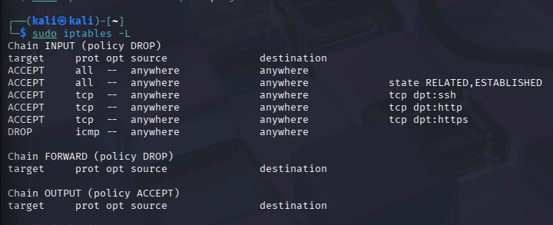

RESULT

Thus, various configurations of the IPTABLES firewall were successfully performed in Linux to control network traffic and enhance system security.

